PROJECT TITLE: FAKE NEWS DETECTION AND VERIFICATION TOOLS



NAME: HEMA KUMARI K S
MENTOR NAME: V. MANJULADEVI
STUDENT EMAIL ID: hemakumari1555@gmail.com
COLLEGE NAME: MAHENDRA COLLEGE OF ENGINEERING

Introduction
In today’s digital era, social media platforms and online news portals have become the primary source of information. While this enables faster communication, it also increases the spread of fake news and misinformation. Fake news can manipulate public opinion, cause social unrest, and lead to serious consequences in areas such as politics, health, and finance.
Manual verification of news articles is time-consuming and prone to errors. Therefore, an automated system is required to analyze news content and determine its authenticity. This project uses Machine Learning (ML) and Natural Language Processing (NLP) techniques to detect and verify fake news based on textual analysis.
The system processes news articles, extracts meaningful features, and classifies them as Real or Fake using trained ML models.

2. Key Outcomes
The successful implementation of this project provides the following outcomes:
- Automated detection of fake and real news articles
- Reduction in misinformation spread on digital platforms
- High accuracy using machine learning classification techniques
- Improved reliability of online news consumption
- Faster news verification compared to manual methods
- Enhanced understanding of NLP and ML concepts
- Scalable framework for future enhancements

3. Modules
Module 1: Data Collection
- Collects dataset containing fake and real news
- Data stored in CSV format
- Includes news content and corresponding labels

Module 2: Data Preprocessing
- Removal of unwanted symbols and punctuation
- Conversion of text to lowercase
- Stop-word removal
- Tokenization and normalization

Module 3: Feature Extraction
- Converts textual data into numerical vectors
- Uses TF-IDF (Term Frequency–Inverse Document Frequency)
- Captures important keywords and patterns

Module 4: Model Training
- Trains machine learning models using processed data
- Algorithms used:
  - Logistic Regression
  - Naive Bayes
  - Passive Aggressive Classifier
- Models learn to distinguish between fake and real news

Module 5: Model Evaluation
- Accuracy and performance evaluation
- Confusion matrix analysis
- Comparison of multiple models

Module 6: Prediction Module
- Accepts user-input news text
- Predicts output as Fake or Real
- Displays result instantly

4. System Architecture
The system architecture represents the overall structure of the Fake News Detection system and explains how data flows from the user to the final prediction.

1. User Interface (UI)
Description:
- This is the interaction layer between the user and the system.
- The user enters the news article text manually.
- It can be implemented using:
  - Web interface (Flask / HTML forms)
  - Command-line interface
Functionality:
- Accepts user input
- Sends the input to the backend for processing
- Displays the prediction result (Fake / Real)
Importance:
- Makes the system user-friendly
- Allows real-time verification of news articles

2. Data Input (News Article)
Description:
- The system receives raw text data from the user.
- The input may contain:
  - Uppercase and lowercase letters
  - Punctuation
  - Stop words
  - Irrelevant symbols
Example Input:
"Breaking news! Scientists discovered a miracle cure overnight."
Role:
- Acts as the initial dataset for prediction
- Sent to preprocessing module for cleaning

3. Text Preprocessing
Description:
This module cleans and prepares raw text data so that it can be understood by machine learning models.
Operations Performed:
- Convert text to lowercase
- Remove punctuation and special characters
- Remove stop words (is, the, and, etc.)
- Tokenization (splitting text into words)
- Lemmatization or stemming
Why Preprocessing is Important:
- Improves model accuracy
- Removes noise from data
- Converts unstructured text into structured format

4. Feature Extraction (TF-IDF)
Description:
- Converts cleaned text into numerical values.
- Uses TF-IDF (Term Frequency–Inverse Document Frequency) technique.
TF-IDF Meaning:
- TF (Term Frequency): How often a word appears in a document
- IDF (Inverse Document Frequency): Importance of a word across documents
Example:
Text → ["fake", "news", "spread"]
Vector → [0.21, 0.45, 0.33]
Importance:
- ML models work only with numbers
- Helps identify important words that distinguish fake and real news

5. Machine Learning Model
Description:
- This module contains trained machine learning algorithms.
- The model is trained using labeled datasets (fake and real news).
Algorithms Used:
- Logistic Regression
- Naive Bayes
- Passive Aggressive Classifier
Role:
- Learns patterns from historical data
- Predicts whether the input news is fake or real

6. Result Output (Fake / Real)
Description:
- Displays the final prediction result to the user.
- Output is binary:
  - Fake News
  - Real News
Example Output:
Prediction Result: FAKE NEWS
Importance:
- Helps users verify information instantly
- Prevents misinformation spread

SYSTEM ARCHITECTURE
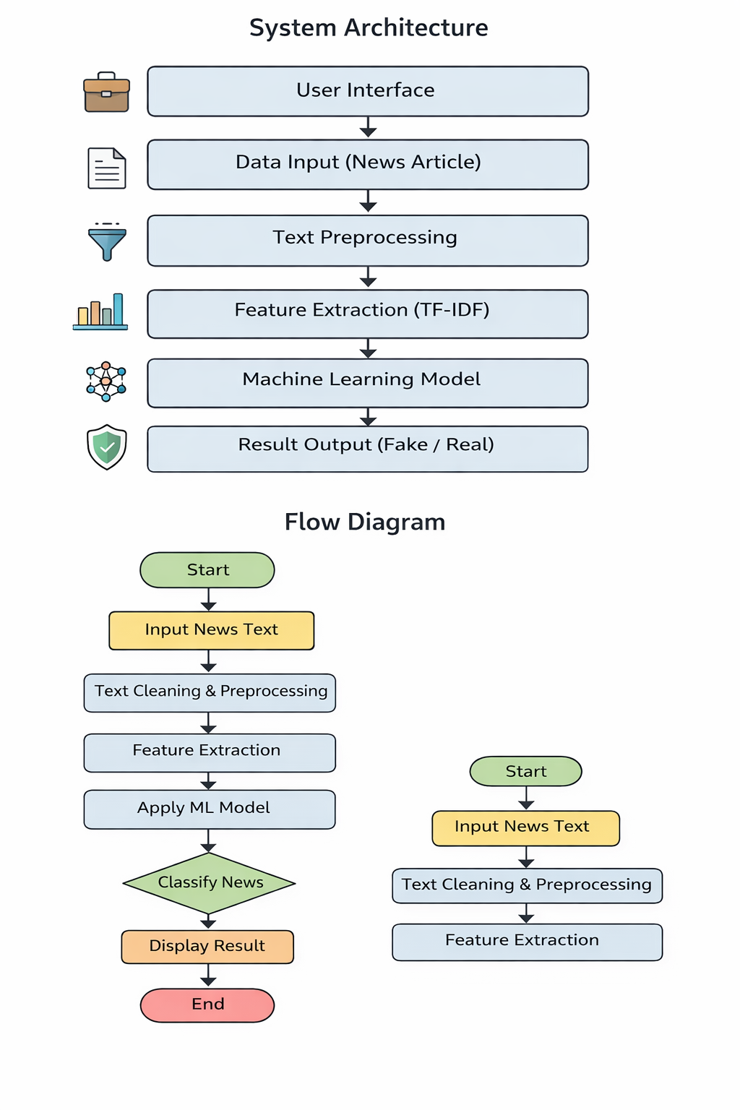

5. Flow Diagram
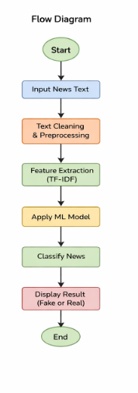
6. Data Schema
Attribute Name | Data Type | Description
id | Integer | Unique identifier
title | String | Title of the news
text | Text | News article content
label | Integer | 0 – Fake, 1 – Real

8.SAMPLE OUTCOME


.

7. Future Enhancements
The project can be extended in the following ways:
- Integration of Deep Learning models such as LSTM and BERT
- Real-time news verification using live news APIs
- Multilingual fake news detection
- Browser extension for automatic verification
- Image and video-based fake news detection
- Cloud deployment for large-scale usage
- User feedback mechanism to improve model accuracy

8. Conclusion
Fake news detection is a critical challenge in the modern digital world. This project demonstrates an effective approach to automatically classify news articles using machine learning and NLP techniques. The system successfully analyzes news content and predicts its authenticity with high accuracy.
By automating the verification process, the solution reduces human effort, minimizes misinformation spread, and enhances trust in online information. The project provides a strong foundation for future research and real-world deployment in combating fake news.

